Q1 | Download a small sample of your recent Zomato order history as a CSV (or create a mock CSV with restaurant names and order dates), then use pandas' duplicated() function to find and print any duplicate orders based on restaurant name and date.
Code | import pandas as pd  df = pd.read_csv("zomato_orders.csv")  duplicates = df[df.duplicated(  subset=["restaurant_name", "order_date"],  keep=False  )]  print("Duplicate Orders:")  print(duplicates)
Output | 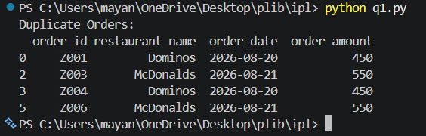

Q2 | Given a list of Flipkart product reviews with some duplicate entries, use value_counts() in pandas to identify which review texts are repeated most often and display the top 3 most common duplicate reviews.
Code | import pandas as pd  df = pd.read_csv("flipkart_reviews.csv")  review_counts = df["review"].value_counts()  print("Top 3 Most Common Reviews:")  print(review_counts.head(3))
Output | 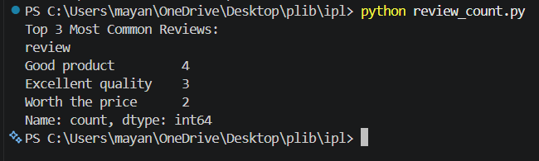

Q3 | Create a DataFrame with mock data for Spotify playlists, including playlist names and creator usernames, where some rows are exact duplicates. Use drop_duplicates() to remove duplicate playlists and print the cleaned DataFrame.
Code | import pandas as pd  data = {  "playlist_name": [  "Top Hits 2026",  "Chill Vibes",  "Workout Music",  "Top Hits 2026",  "Party Songs",  "Chill Vibes",  "Road Trip",  "Workout Music"  ],  "creator_username": [  "amit123",  "riya_music",  "rahul99",  "amit123",  "neha_music",  "riya_music",  "vivek_playlist",  "rahul99"  ]  }  df = pd.DataFrame(data)  print("Original DataFrame:")  print(df)  cleaned_df = df.drop_duplicates()  print("\nCleaned DataFrame:")  print(cleaned_df)
Output | 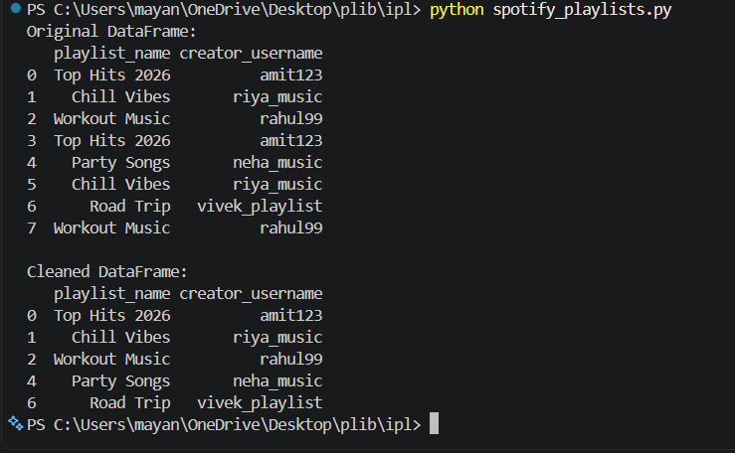

Q4 | Suppose you have a DataFrame of Instagram usernames where some entries have typos (like 'insta_queen', 'insta-queen', 'instaqueen'). Use the replace() function to standardize all these variants to 'instaqueen'.
Code | import pandas as pd  df = pd.DataFrame({  "username": [  "insta_queen",  "insta-queen",  "instaqueen",  "insta_queen",  "insta-queen",  "instaqueen",  "john123"  ]  })  print("Original DataFrame:")  print(df)  df["username"] = df["username"].replace({  "insta_queen": "instaqueen",  "insta-queen": "instaqueen"  })  print("\nUpdated DataFrame:")  print(df)
Output | 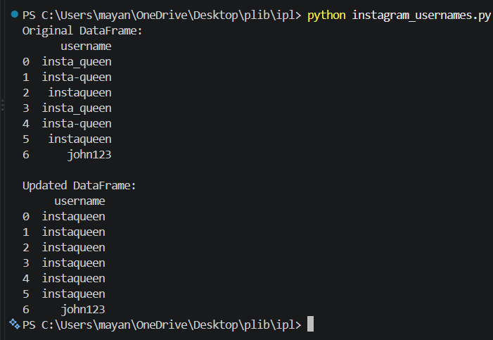

Q5 | You have a DataFrame column for payment status from a Paytm-like app with mixed values: 'Yes', 'yes', 'Y', 'No', 'no', 'N', and some with extra spaces. Write code to unify this column so all paid statuses become 1 and all unpaid statuses become 0, trimming whitespace and fixing capitalization where needed.<br><br><em><strong>Hint:</strong> Use str.strip(), str.lower(), and map/replace methods in pandas.</em>
Code | import pandas as pd  df = pd.DataFrame({  "payment_status": [  "Yes",  " yes ",  "Y",  "No",  " no ",  "N",  " YES ",  " y ",  " NO "  ]  })  print("Original DataFrame:")  print(df)  df["payment_status"] = df["payment_status"].str.strip().str.lower()  df["payment_status"] = df["payment_status"].map({  "yes": 1,  "y": 1,  "no": 0,  "n": 0  })  print("\nUpdated DataFrame:")  print(df)
Output | 